Case ID | 2600130362 | Sample Type | FFPE TISSUE BLOCK
Name | MR. AGATAMUDI VENKATA KAMANA | Sex/Age | Male/61 Years
Date & Time Received | 15-Apr-2026 04:44 PM | Date & Time Reported | 28-Apr-2026 06:16 PM
Report Version | 1

Brainseq Genomic Profiling Panel – Advance
On Illumina Novaseq 6000 Platform
Clinical Indication: Features are consistent with recurrent astrocytoma, IDH - mutant, CNS WHO grade 4 Block No.: 24-4733-B2
Positive (Clinically significant Variant detected)
Report Highlights:

Tier I | Tier II | Tier III | MSI | Therapies | Clinical Trials
2 | 0 | 0 | Stable | 2 | 18

Key Findings:

Tier | Gene & Transcript | Variant | Exon | Coverage/VAF
IA | IDH1  NM 005896.4  _ | c.395G>A  p.(R132H) | 4 | 890x / 47.19%
IA | TERT  NM 198253.3  _ | c.-124C>T  (Upstream Mutation) | - | 410x / 36.36%

- Genetic test results are reported based on the recommendations of AMP-ASCO-CAP guidelines. **Public data sources included in relevant targeted therapies, guidelines: EMA, FDA, ESMO, NCCN.

Biomarkers Results:

Assay Biomarker | Result | Interpretation
Microsatellite Instability (MSI) | Stable | Stable Microsatellite detected
MGMT Methylation Status | Positive | MGMT Methylation and TERT C228T, IDH1 R132H Mutation  Detected
FISH 1p19q Co-Deletion | Positive | nuc ish(1p36×1,1q25×2)[45] / nuc ish(1p36×2,1q25×2)[05]  nuc ish(19q13×1,19p13×2)[48] / nuc ish(19q13×2,19p13×2)[03]

MLPA Findings:
Data from Clinical Sample
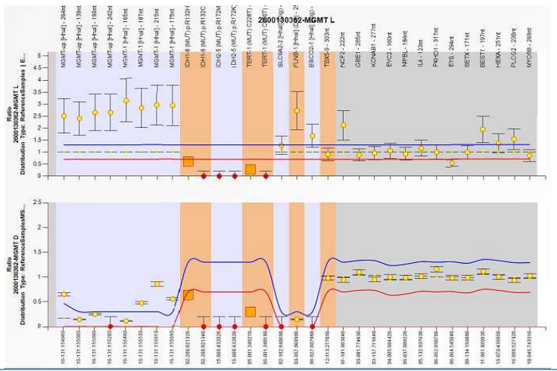

FISH Findings:
Data from Clinical Sample
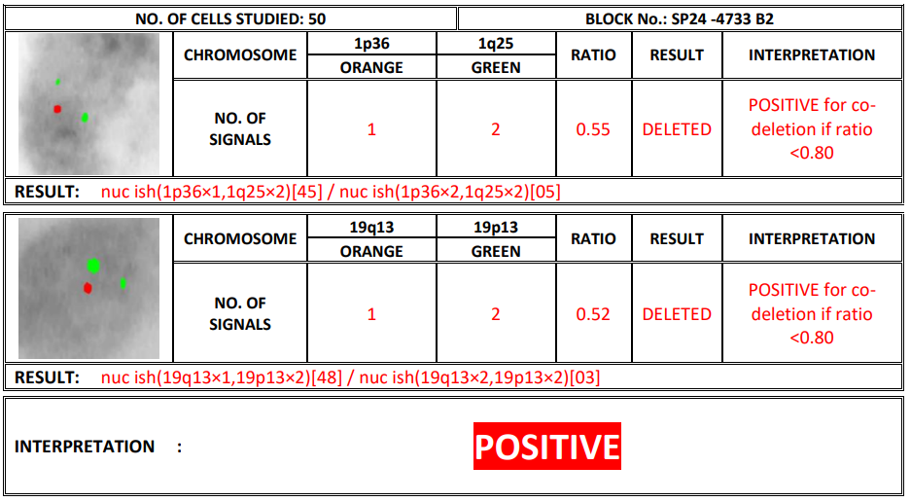
Clinical Significance:

Variant | Therapy | Column 3
 | In This Cancer | In Other Cancer
IA  IDH1  p.(R132H) | ▪ivosidenib  ▪vorasidenib | ▪ivosidenib  ▪vorasidenib

Variant | Diagnostic Significance | Prognostic Significance
IDH1  p.(R132H) | Page 3 of 15  Astrocytoma IDH-mutant (Grade 4) | NCCN: Favorable

Biomarker Description:

Variant | Biomarker Description
IDH1  NM 005896.4  _  chr2:209113112  c.395G>A  p.(R132H) | The IDH1 and IDH2 genes encode homologous isocitrate dehydrogenase enzymes that catalyze the  conversion of isocitrate to α-ketoglutarate (α-KG)[1]. The IDH1 gene encodes the NADP+ dependent  cytoplasmic isocitrate dehydrogenase enzyme; IDH2 encodes the mitochondrial isoform[1].  Recurrent somatic mutations in IDH1 and IDH2 are mutually exclusive and observed in several  malignancies, including glioma, chondrosarcoma, intrahepatic cholangiocarcinoma, acute myeloid  leukemia (AML), and myelodysplastic syndrome (MDS)[2]. Recurrent IDH1 variants include  predominantly R132H/C plus other substitutions at lower frequencies[3]. These gain-of-function  variants confer neomorphic enzyme activity[4]. Although wild-type enzymatic activity is ablated,  recurrent IDH1 variants catalyze the conversion of α-KG to D-2-hydroxyglutarate, an oncometabolite  with diverse effects on cellular metabolism, epigenetic regulation, redox states, and DNA repair[1,5].  Recurrent IDH1 mutations are present in 5-10% of patients with AML and 5% of patients with  MDS[6,7,8]. Recurrent IDH1 mutations are present in nearly 80% of lower-grade diffuse  gliomas[9,10]. Alterations in IDH1 are rare in pediatric cancers[9,10]. Somatic mutations in IDH1 are  observed in 2% of glioma and less than 1% of leukemia (2 in 311 cases), B-lymphoblastic  leukemia/lymphoma (1 in 252 cases), embryonal tumor (1 in 332 cases), and Wilms tumor (1 in 710  cases)[9,10].  The IDH1 and IDH2 inhibitor vorasidenib[11] is FDA-approved (2024) for the treatment of adults  and children with Grade 2 astrocytoma and oligodendroglioma with IDH1 R132C/G/H/L/S  mutations. Additionally, olutasidenib[12] (2022) and ivosidenib[13] (2018) are FDA-approved for  treating IDH1 R132C/G/H/L/S variants in AML. Ivosidenib is also approved for treating  myelodysplastic syndrome (MDS) and cholangiocarcinoma patients with the same IDH1  variants[14]. IDH1 mutations are associated with favorable outcome in lower-grade gliomas,  astrocytoma, and oligodendroglioma with 1p/19 codeletion[15,16,17]. Conversely, IDH1 mutations  are associated with inferior leukemia-free survival in primary myelofibrosis (PMF)[18,19].  Mutations in IDH1 are diagnostic of IDH-mutated astrocytoma and oligodendroglioma with 1p/19q-  codeletion subtypes of central nervous system (CNS) tumors[15,20].  ivosidenib  TIBSOVO® is an isocitrate dehydrogenase-1 (IDH1) inhibitor indicated for the treatment of adult  patients with a susceptible IDH1 mutation as detected by an FDA-approved test with:  Newly Diagnosed Acute Myeloid Leukemia (AML)  Page 5 of 15  • In combination with azacitidine or as monotherapy for the treatment of newly diagnosed AML in  adults 75 years or older, or who have comorbidities that preclude use of intensive induction

Variant | Biomarker Description
chemotherapy.
Relapsed or refractory AML
• For the treatment of adult patients with relapsed or refractory AML.
Relapsed or refractory Myelodysplastic Syndromes (MDS)
• For the treatment of adult patients with relapsed or refractory myelodysplastic syndromes.
Locally Advanced or Metastatic Cholangiocarcinoma
• For the treatment of adult patients with locally advanced or metastatic cholangiocarcinoma who
have been previously treated.
Cancer type: Cholangiocarcinoma
TERT  NM 198253.3  _  chr5:1295228  c.-124C>T  (Upstream  Mutation) | The TERT gene encodes telomerase reverse transcriptase, a component of the telomerase core  enzyme along with the internal telomerase RNA template (TERC)[21]. TERT is repressed in most  differentiated cells, resulting in telomerase silencing[21]. In cancer, telomerase reactivation is  known to contribute to cellular immortalization[21,22]. Increased TERT expression results in  telomerase activation, allowing for unlimited cancer cell proliferation through telomere  stabilization[21]. In addition to its role in telomere maintenance, TERT has RNA-dependent RNA  polymerase activity, which, when deregulated, can promote oncogenesis by facilitating mitotic  progression and cancer cell stemness[21].  Alterations and prevalence Somatic mutations are observed in 4% of skin cutaneous  melanoma and uterine corpus endometrial carcinoma, 3% of kidney renal papillary cell carcinoma,  and 2% of pancreatic adenocarcinoma, stomach adenocarcinoma, and sarcoma[9,10]. Additionally,  TERT promoter mutations causing upregulation are observed in many cancer types, especially non-  aural cutaneous melanoma (80% of cases), and glioblastoma (70% of cases)[22]. Specifically, TERT  promoter mutations at C228T and C250T are recurrent and result in de novo binding sites for ETS  transcription factors, leading to enhanced TERT transcription[21]. Amplification of TERT is observed  in 15% of lung squamous cell carcinoma, 14% of esophageal adenocarcinoma, 13% of adrenocortical  carcinoma and lung adenocarcinoma, and 10% of bladder urothelial carcinoma, 9% of ovarian  serous cystadenocarcinoma, 6% of cervical squamous cell carcinoma, 5% of liver hepatocellular  carcinoma, sarcoma, skin cutaneous melanoma, stomach adenocarcinoma, head and neck squamous  cell carcinoma, 4% of uterine carcinosarcoma, 3% of uterine corpus endometrial carcinoma, breast  invasive carcinoma, and 2% of diffuse large B-cell lymphoma[9,10]. TERT is overexpressed in over  85% of tumors and is considered a universal tumor associated antigen[23]. Alterations in TERT are  rare in pediatric cancers[9,10]. Somatic mutations are observed in less than 1% of B-lymphoblastic  leukemia/lymphoma (2 in 252 cases)P,a ggeli o6m ofa 1 5(2 in 297 cases), bone cancer (1 in 327 cases), and  Wilms tumor (1 in 710 cases)[9,10]. TERT amplification is observed in 1-2% of peripheral nervous

Variant | Biomarker Description
system cancers (2 in 91 cases), leukemia (2 in 250 cases), and B-lymphoblastic leukemia/lymphoma
(5 in 731 cases)[9,10].
Potential relevance Currently, no therapies are approved for TERT aberrations. TERT promoter
mutations are diagnostic of oligodendroglioma IDH-mutant with 1p/19q co-deletion, while the
absence of promoter mutations combined with an IDH mutation is characteristic of
astrocytoma[15,24]. Due to its immunogenicity and near-universal expression on cancer cells, TERT
has been a focus of immunotherapy research, including peptide, dendritic, and DNA vaccines as well
as T-cell therapy[23].

Therapy & Clinical Trials:
IDH1 p.(R132H) c.395G>A

Therapy | FDA | NCCN | EMA | ESMO | Trials
ivosidenib | ✓ | ✓✓ | ✓ | ✓
vorasidenib | ✓ | ✓✓ | X | X
olaparib, durvalumab | X | X | X | X | II
olutasidenib, chemotherapy | X | X | X | X | II
supplement, retifanlimab | X | X | X | X | II
talazoparib | X | X | X | X | II
avutometinib, defactinib | X | X | X | X | I/II
AZD-9574, chemotherapy | X | X | X | X | I/II
NEO-212 | X | X | X | X | I/II
ribociclib, chemotherapy | X | X | X | X | I/II
vorasidenib, chemotherapy | X | X | X | X | I/II
zotiraciclib | X | X | X | X | I/II
ABBV-706 Pag | e 7 of X15 | X | X | X | I

Therapy | FDA | NCCN | EMA | ESMO | Trials
amivantamab | X | X | X | X | I
ASKC-202 | X | X | X | X | I
chemotherapy, pamiparib | X | X | X | X | I
MT-001 (Meton Pharmaceuticals) | X | X | X | X | I
MVR-C5252 | X | X | X | X | I
tasadenoturev | X | X | X | X | I
TGFβR2KO/IL13Rα2 CAR T-cells | X | X | X | X | I

Note | ✓ : In this Cancer Type, ✓ : In Other Cancer Type, ✓ ✓ : both In this and Other Cancer Type, X : No

Test Description
Brainseq Genomic Profiling Panel - Advance is advancing precision oncology research through the analysis of multiple relevant biomarkers in a single next-generation sequencing (NGS) test.
The Brainseq Genomic Profiling Panel – Advance assay analyses 89 unique genes ( 62 DNA + 27 RNA) for single gene and multiple gene biomarker insights, detects single gene biomarkers from all variant types including SNVs, indels, CNVs, known and novel fusions, and splice variants , analyze complex multi-gene biomarkers for mutational signatures, microsatellite instability ( MSI ) for immunotherapy research, MGMT methylation status & FISH for 1p19q co-deletion .
The performance of the panel was verified using both commercially sourced reference controls and FFPE samples.
Test Methodology Extraction & Library Preparation: DNA & RNA extracted from FFPE tissue block sample is used for targeted gene capture using a custom designed hybrid capture panel. In process quality controls were determined for prepared library.

Sequencing | The libraries were sequenced at mean depth: >1000x on Illumina Novaseq- next generation

Data Analysis | Sequencing data are analyzed using a customized and validated bioinformatics pipeline

Limit of Detection (LOD): The LOD for SNVs and InDels is 5% Variant allele Frequency (VAF) and for Fusions is ≥10 supporting reads.
MLPA:
MGMT Methylation Analysis is based on the MS-MLPA technology (Methylation Specific Multiplex Ligation- dependent Probe Amplification) and employs the SALSA® MLPA® probe mixes available from MRC (Holland).
FISH :
1p36 and 19q13 – co-deletion By Fluorescence in situ Hybridization (FISH).
Healthcare 1p Dual color gene detection Probes Orange: 1p36, Green: 1q25.
Healthcare 19q Dual color gene detection Probes Orange: 19q13, Green: 19p13
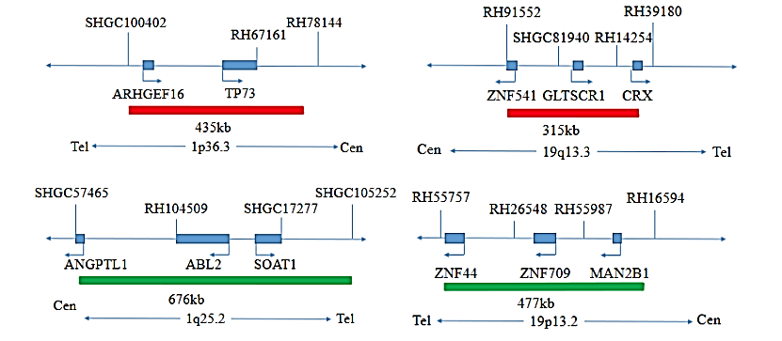
Related Biomarker Information MGMT Methylation:

Epigenetic silencing of the MGMT (O6‐methylguanine–DNA methyltransferase) DNA repair gene by promoter methylation compromises DNA repair mechanism and has been associated with better response to treatment and longer overall survival in glioma patients treated with alkylating agents.

Biology of the process | MGMT is a DNA repair enzyme that reverses alkylation of guanine by transferring the

Clinical indications for MGMT promoter methylation testing include high grade glioma (anaplastic astrocytoma or glioblastoma) patient being considered for therapy with an alkylating agent, or glioma patient being considered for temozolomide therapy.
FISH 1p/19q co-deletion:
The presence of 1p/19q co-deletion predicts a better response to chemotherapy (such as temozolomide) and radiotherapy, which are standard treatments for oligodendrogliomas.
Patients with 1p/19q co-deletion generally have a better prognosis, meaning a longer survival and slower disease progression. The World Health Organization (WHO) classification of gliomas considers 1p/19q co- deletion status essential for a complete diagnosis of oligodendrogliomas.
Notes
Treatment decisions should not be based solely on the results of this test. Findings must be interpreted in the context of the patient’s complete clinical profile—including pathological, radiological, and family history—to guide diagnosis, prognosis, and therapeutic decisions.
Therapy-related information in this report is derived from multiple sources including FDA-approved drug data, NCCN guidelines, peer-reviewed literature, standard clinical databases, and biomarker evidence strength. However, therapy options listed may not be suitable or beneficial for all patients. This report aims to provide a summary of potentially effective treatments, therapies that may pose increased risks, and those that may have limited benefit, based on genomic alterations identified. Prognostic and diagnostic biomarkers relevant to the disease context may also be reported. Page 10 of 15

Laboratory does not guarantee completeness, accuracy, or eligibility for trial enrollment. Physicians must verify eligibility criteria for specific trials independently.
Identification of a genomic alteration does not guarantee therapeutic efficacy or predict ineffectiveness. Final decisions on treatment should rest with the treating physician. The absence of reported therapeutic options does not imply ineffectiveness or lack of safety of any medication selected independently.
All variant classifications and related clinical information are based on the latest evidence from peer- reviewed publications, public clinical databases, and medical guidelines (e.g., NCCN, ASCO, AMP) available at the time of report generation. However, literature is continuously evolving, and classification may change with emerging evidence.
This test is performed on tumor tissue without a matched normal (e.g., blood) sample. Therefore, some variants may be of germline origin. While the assay is designed and validated for somatic variant detection, it does not differentiate between somatic and germline variants. If indicated, germline testing and genetic counselling are recommended.
FFPE-derived samples often pose challenges due to degradation. Poor-quality DNA or RNA may fail QC thresholds at various stages such as extraction, library preparation, or bioinformatics, and may result in assay failure or compromised results, such as low gene coverage or shallow variant depth. TMB score may be influenced by cytosine deamination artifacts (C>T transitions), especially in poorly fixed tissues.
Variants with allele frequencies between 3–5% may be reported if they are of strong or potential clinical relevance, or if previously detected in the same patient. False positives or negatives below assay sensitivity cannot be ruled out.
CNVs/gene amplifications have >80% detection sensitivity in this assay. Confirmation using orthogonal methods such as FISH/DDPCR is recommended when clinically indicated.
Variants in non-coding regions or deep intronic sequences are not assessed in this assay.
This assay is under the scope of NABL as Solidseq Comprehensive panel. Page 11 of 15

DNA Gene List | Column 2 | Column 3 | Column 4 | Column 5
AKT1 | APC | ATRX | BAP1 | BCOR
BCORL1 | BRAF | CDK6 | CDKN2A | CDKN2B
CIC | CTNNB1 | DICER1 | EED | EGFR
EPCAM | ERBB2 | ERBB4 | FGFR1 | FGFR2
FGFR3 | FUBP1 | GNA11 | GNAQ | H3F3A
HIST1H3C | HRAS | IDH1 | IDH2 | KDM6A
KRAS | MAP2K1 | MET | MLH1 | MSH2
MSH6 | MYC | MYCN | NF1 | NF2
NOTCH1 | NRAS | PDGFRA | PIK3CA | PMS2
PTCH1 | PTEN | RB1 | SETD2 | SF3B1
SMAD4 | SMARCA4 | SMARCB1 | SMO | SRC
SUFU | SUZ12 | TERT | TP53 | TSC1
TSC2 | VHL

RNA Gene List | Column 2 | Column 3 | Column 4 | Column 5
ALK | BRAF | CIC | EGFR | EML4
ETV6 | EWSR1 | FGFR1 | FGFR2 | FGFR3
FUS | KIAA1549 | MAML2 | MET | MN1
MYB | MYBL1 | NTRK1 | NTRK2 | NTRK3
PRKCA | RAF1 | ROS1 | STAT6 | TACC3
TFG | YAP1

MSI | % of Unstable Loci
MSI - Stable | 0-19%
MSI - Low / Intermediate | 20-30%
MSI - High | >30%

MGMT Methylation | Column 2
Methylation ratio of a probe in test sample > baseline | Methylation is increased
Methylation ratio of a probe in test sample ≤baseline | Methylation is not increased

FISH 1p19q Co-Deletion | Page 12 of 15
Negative | If ratio is >0.80

FISH 1p19q Co-Deletion | Page 12 of 15
Positive | If ratio is <0.80

Tier | Interpretation
Tier IA | Variants of Strong Clinical Significance: Biomarkers that predict response or resistance to  US FDA-approved therapies for a specific type of tumor or have been included in  professional guidelines as therapeutic, diagnostic, and/or prognostic biomarkers for  specific types of tumors.
Tier IB | Variants of Strong Clinical Significance: Biomarkers that predict response or resistance to  a therapy based on well-powered studies with consensus from experts in the field, or  have diagnostic and/or prognostic significance of certain diseases based on well-powered  studies with expert consensus.
Tier IIC | Variants of Potential Clinical Significance: biomarkers that predict response or resistance  to therapies approved by FDA or professional societies for a different tumor type (i.e., off-  label use of a drug), serve as inclusion criteria for clinical trials, or have diagnostic and/or  prognostic significance based on the results of multiple small studies.
Tier IID | Variants of Potential Clinical Significance: Biomarkers that show plausible therapeutic  significance based on preclinical studies or may assist disease diagnosis and/or prognosis  themselves or along with other biomarkers based on small studies or multiple case  reports with no consensus.
Tier III | Variants of Unknown clinical significance (VUS): Not observed at a significant allele  frequency in the general or specific subpopulation or pancancer or tumor specific variant  databases. No convincing published evidence of cancer Association

References:
1. Molenaar et al. Wild-type and mutated IDH1/2 enzymes and therapy responses. Oncogene. 2018 Apr;37(15):1949-1960. PMID: 29367755
2. Yan et al. IDH1 and IDH2 mutations in gliomas. N. Engl. J. Med. 2009 Feb 19;360(8):765-73. PMID: 19228619
3. Lu et al. Isocitrate dehydrogenase 1 mutation subtypes at site 132 and their translational potential in glioma. CNS Oncol. 2018 Jan;7(1):41-50. PMID: 29303363
4. Dang et al. Cancer-associated IDH1 mutations produce 2-hydroxyglutarate. Nature. 2009 Dec 10;462(7274):739-44. PMID: 19935646 Page 13 of 15

5. Ward et al. The common feature of leukemia-associated IDH1 and IDH2 mutations is a neomorphic enzyme activity converting alpha-ketoglutarate to 2-hydroxyglutarate. Cancer Cell. 2010 Mar 16;17(3):225-34. PMID: 20171147
6. Paschka et al. IDH1 and IDH2 mutations are frequent genetic alterations in acute myeloid leukemia and confer adverse prognosis in cytogenetically normal acute myeloid leukemia with NPM1 mutation without FLT3 internal tandem duplication. J. Clin. Oncol. 2010 Aug 1;28(22):3636-43. PMID: 20567020
7. Chou et al. The prognostic impact and stability of Isocitrate dehydrogenase 2 mutation in adult patients with acute myeloid leukemia. Leukemia. 2011 Feb;25(2):246-53. PMID: 21079611
8. Marcucci et al. IDH1 and IDH2 gene mutations identify novel molecular subsets within de novo cytogenetically normal acute myeloid leukemia: a Cancer and Leukemia Group B study. J. Clin. Oncol. 2010 May 10;28(14):2348-55. PMID: 20368543
9. Weinstein et al. The Cancer Genome Atlas Pan-Cancer analysis project. Nat. Genet. 2013 Oct;45(10):1113-20. PMID: 24071849
10. Cerami et al. The cBio cancer genomics portal: an open platform for exploring multidimensional cancer genomics data. Cancer Discov. 2012 May;2(5):401-4. PMID: 22588877
11. https://www.accessdata.fda.gov/drugsatfda_docs/label/2025/218784s002lbl.pdf
12. https://www.accessdata.fda.gov/drugsatfda_docs/label/2022/215814s000lbl.pdf
13. https://www.accessdata.fda.gov/drugsatfda_docs/label/2023/211192s011lbl.pdf
14. Abou et al. The role of enasidenib in the treatment of mutant IDH2 acute myeloid leukemia. Ther Adv Hematol. 2018 Jul;9(7):163-173. PMID: 30013764
15. NCCN Guidelines&amp;reg; - NCCN-Central Nervous System Cancers [Version 5.2024]
16. Cancer Genome Atlas Research Network. Comprehensive, Integrative Genomic Analysis of Diffuse Lower-Grade Gliomas. N Engl J Med. 2015 Jun 25;372(26):2481-98. doi: 10.1056/NEJMoa1402121. Epub 2015 Jun 10. PMID: 26061751
17. Houillier et al. IDH1 or IDH2 mutations predict longer survival and response to temozolomide in low-grade gliomas. Neurology. 2010 Oct 26;75(17):1560-6. PMID: 20975057
18. Vannucchi et al. Mutations and prognosis in primary myelofibrosis. Leukemia. 2013 Sep;27(9):1861-9. PMID: 23619563
19. Tefferi et al. IDH1 and IDH2 mutation studies in 1473 patients with chronic-, fibrotic- or blast-phase essential thrombocythemia, polycythemia vera or myelofibrosis. Leukemia. 2010 Jul;24(7):1302-9. PMID: 20508616
20. Louis et al. The 2021 WHO Classification of Tumors of the Central Nervous System: a summary. Neuro Oncol. 2021 Aug 2;23(8):1231-1251. PMID: 34185076
21. Yuan et al. Mechanisms underlying the activation of TERT transcription and telomerase activity in human cancer: old actors and new players. Oncogene. 2019 Aug;38(34):6172-6183. PMID: 31285550 Page 14 of 15

22. Colebatch et al. TERT gene: its function and dysregulation in cancer. J Clin Pathol. 2019 Apr;72(4):281-284. PMID: 30696697
23. Mizukoshi et al. Telomerase-Targeted Cancer Immunotherapy. Int J Mol Sci. 2019 Apr 12;20(8). PMID: 31013796
24. Arita et al. TERT promoter mutation confers favorable prognosis regardless of 1p/19q status in adult diffuse gliomas with IDH1/2 mutations. Acta Neuropathol Commun. 2020 Nov 23;8(1):201. PMID: 33228806
- End Of Report ------------------
------------------ End Of Report ------------------

